Rättviks skyttegille PRS
Träningsmatch
30maj

Safety:
KEEP DISTANCE AND DO NOT MINGLE WITH OTHER PEOPLE
Safety is paramount and everyone´s responsibility. Anyone who observes an unsafe act or event, can call a “cease fire” at any point during the course of a match.
– All weapons are to be considered loaded at all time.
– Muzzle awareness is crucial. Keep the muzzle pointed in a safe direction at all time.
– All movement shall be done with the bolt open and the chamber empty.
– It´s not allowed to load more rounds in the magazine then the announced “max” for each stage.
– Don´t close the bolt until you´re in position and the have the rifle pointed at the target.
– Keep your finger off the trigger and outside the trigger guard until you are ready to shoot.
– The chamber flag must be placed in the camber until the RO tells you to remove it.
– Cheating equals match DQ and possible exclusion from the Swedish Rifle CUP
– Unsportsmanlike conduct results in a warning, a stage DQ or match a DQ. This assessment is up to the RO and MD and not up for discussion.
– Safe angles of fire will be announced at each stage. Respect these.
Equipment/behavior:
Use the gear you brought, borrow gear from fellow shooters, unless the stage description says otherwise.
Rifles/gear must be placed in the designated area at each stage unless you´re the next shooter in line.
If you have concerns regarding other shooters behavior, bring this up with the RO/MD as soon as possible.
Commands given:
Shooter ready! (if shooter is not ready command repeats when user is ready)
Standby! (competitor stands still in startposition)
Fire! (Beep if time is used) (competitor can start stage)
Time! (once the T in time has been issued shots fired after will not count)

1 – Stegosaurus
Max number of rounds: 8
Range: 310m
Time: 90s
Targets: Round 30cm
Course of fire:
Shooter will start standing with the rifle in hand, magazine in, bolt open, at the designated spot.
At the timer beep, engage the target with two rounds from each of the 4 positions.

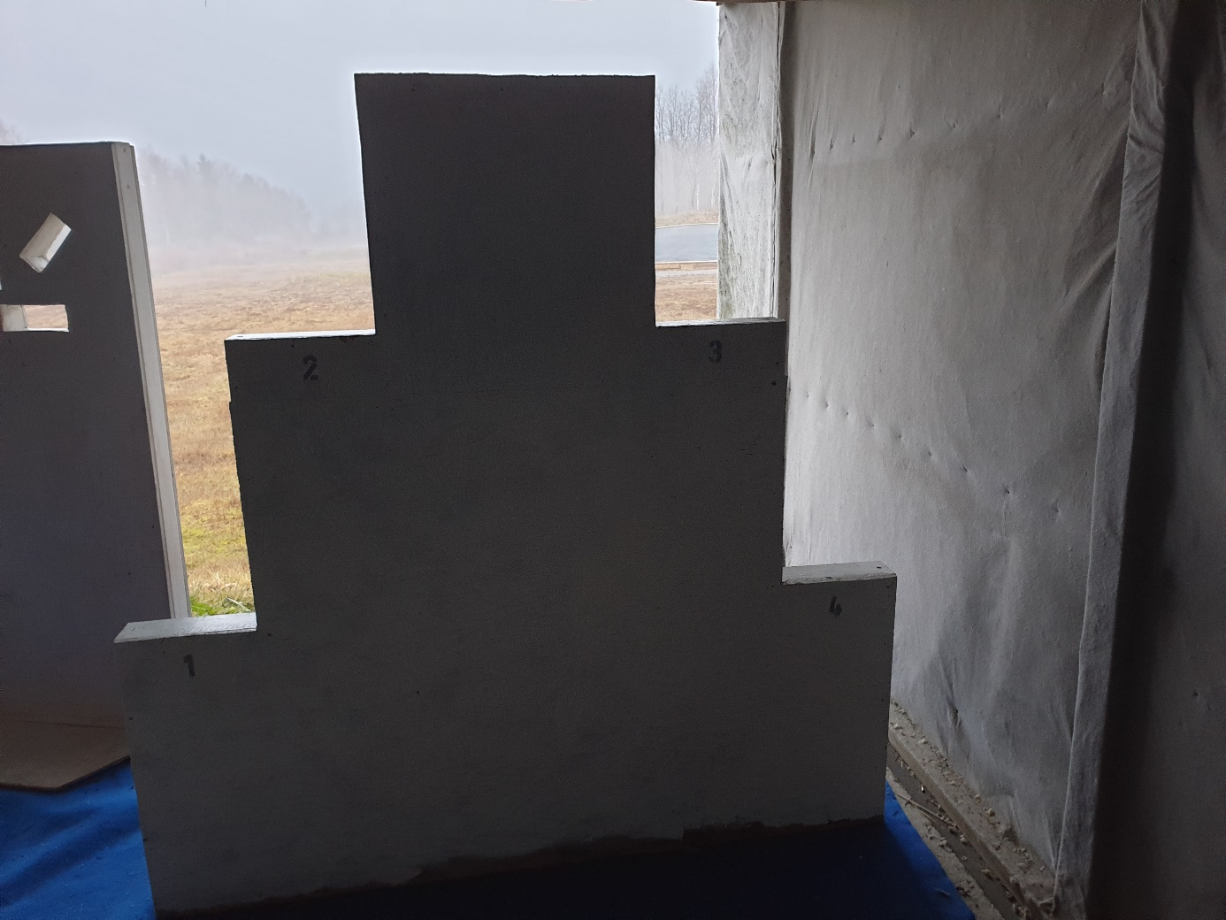

2– Rooftop
Max number of rounds: 6
Range: 310m
Time: 60s
Target: Round 30cm
Course of fire:
Shooter will start standing with the rifle in hand, magazine in, bolt open, at the designated spot.
At the timer beep, mount the barricade and engage target with 3shots on each side
No equipment or body parts touching ground while shooting
Picture show reverse rooftop but we shoot the other way

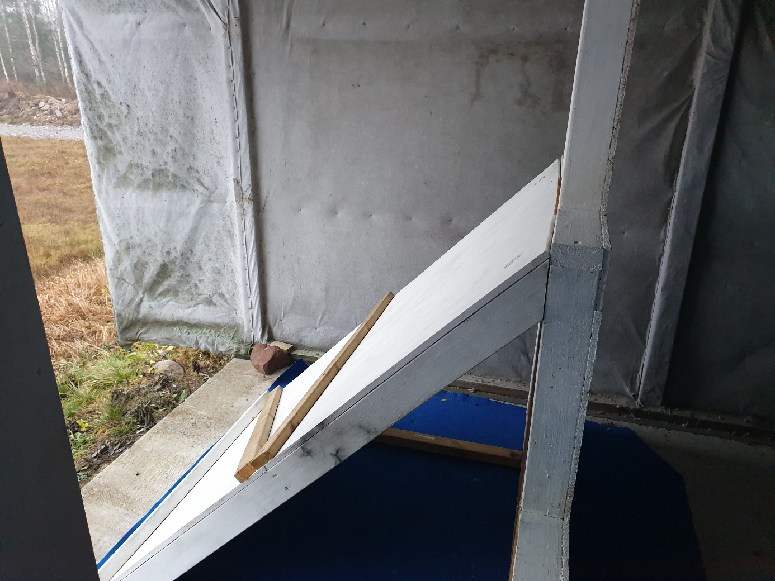

3 – Hanging tire
Max number of rounds: 6
Range: 310m
Time: 60s
Targets: round 30
Course of fire:
Shooter will start standing with the rifle in hand, magazine in, bolt open, at the designated spot.
At the timer beep, engage the target with three shots through tire and then three shots over tire.
No equipment touching ground while shooting
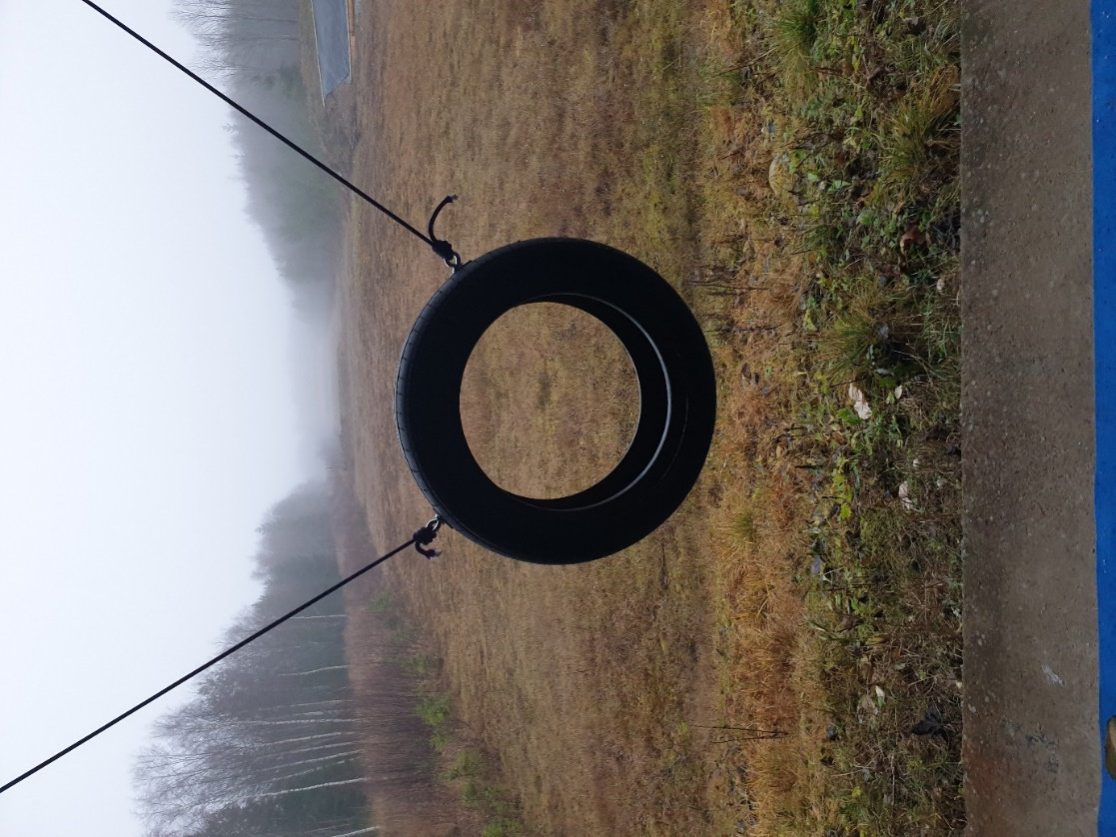

5 - Squeeze
Max number of rounds: 6
Range: 310m
Time: 90s
Target: Round 30cm
Course of fire:
Shooter will start standing with the rifle in hand, magazine in, bolt open, at the designated spot.
At the timer beep, engage the target with one round from each opening

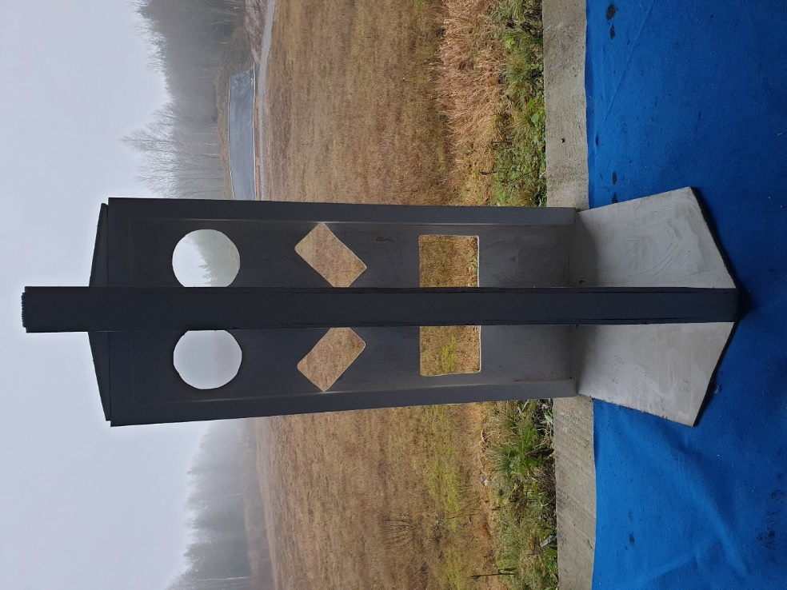

6 - Back to basics
Max number of rounds: 9
Range: 355m
Time: 90s
Target: Round 50cm
Course of fire:
Shooter will start standing with the rifle in hand, magazine in, bolt open, at the designated spot.
At the timer beep, engage the target with three rounds standing, three rounds kneeling or sitting and three rounds prone in named order.
No gear except a sling is allowed.

Classic XC shooting styles only.

Standing any style
Knee: sitting ,kneeling
Lying: no equipment touching ground in classic prone
If shooting jacket is used then it must be used during the whole match

7 – Move it
Max number of rounds: 9
Range: 355
Time: 90s
Targets: 30cm square

Course of fire:
Shooter will start standing with the rifle in hand, magazine in, bolt open, at the designated spot.
At the timer beep, engage target with three shots each from oil barrel, tank trap and electrical drum.
Free order, no equipment touching ground

8 Rack it
Max number of rounds: 6
Range: 505m
Time: 60s
Target:
50cm round (1point each hit)
30cm square (1.5 point each hit)
10cm (2points each hit)
Course of fire:
Shooter will start standing with the rifle in hand, magazine in, open bolt, at the designated spot.
At the timer beep, engage targets by your choice
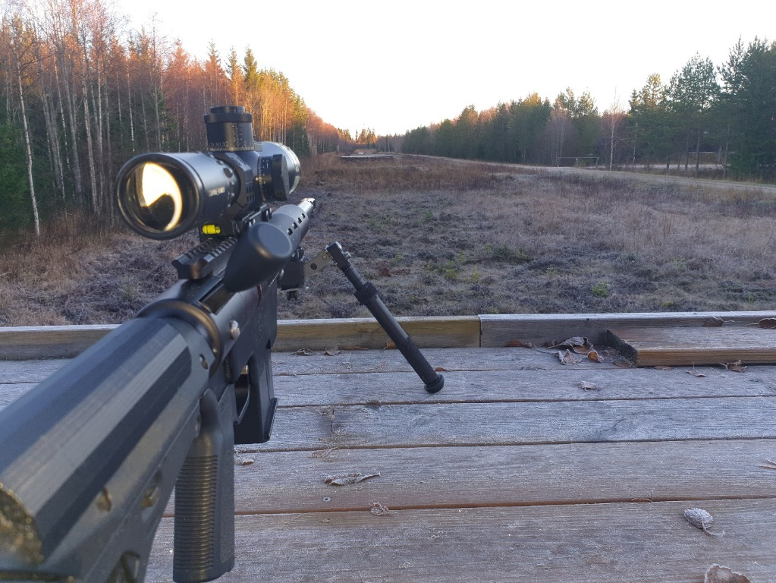

9 – Stubben
Max number of rounds: 5
Range: 505m
Time: 60s
Targets: 50cm square
Course of fire:
Shooter will start standing with the rifle in hand, magazine in, open bolt, at the designated spot.
At the timer beep, engage target one round from each stub
No equipment touching anything but stubs while shooting

